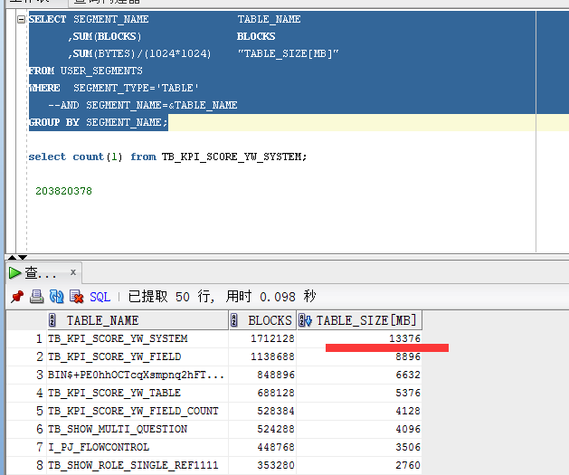

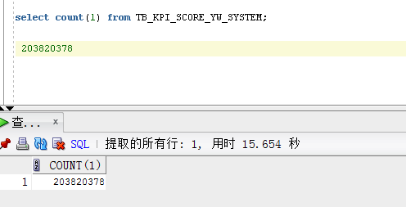

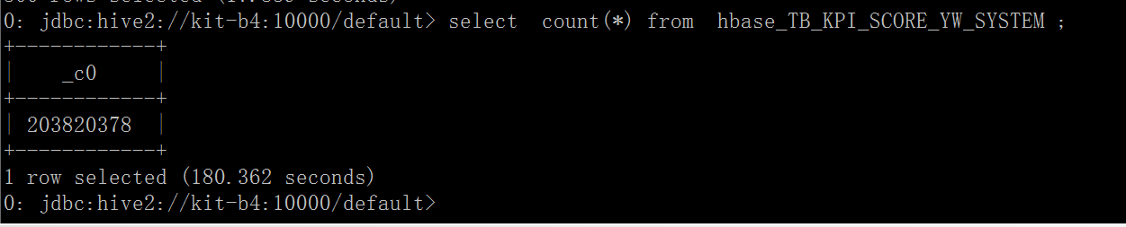

hbase(main):001:0sudo hadoop fs -du -s /hyperbase1/data/KITDEV/TB_KPI_SCORE_YW_SYSTEM

2017-01-10 14:56:41,682 INFO util.KerberosUtil: Using principal pattern: HTTP/_HOST

93920047014 /hyperbase1/data/KITDEV/TB_KPI_SCORE_YW_SYSTEM

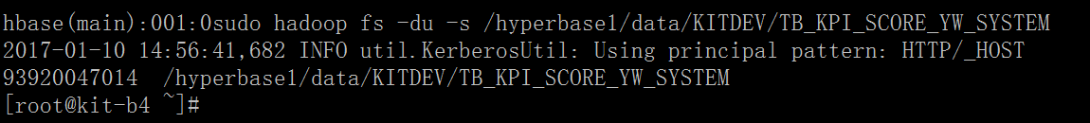

|  |  |  |  |  |
| --- | --- | --- | --- | --- |
| oracle表名 | Oracle表容量(mb) | Hbase表名 | Hbase容量(byte) | 查询耗时（count/ms） |
| MREQ_APP_STORE_MATL_IN_OUT | 2 | KITDEV:MREQ_APP_STORE_MATL_IN_OUT | 7543361(7m) | 10/746 |
| MREQ_APP_STORE_MATL_IN_OUT | 2 | KITDEV:MREQ_APP_STORE_MATL_IN_OUT | 7543361(7m) | 100/443 |
| MREQ_APP_STORE_MATL_IN_OUT | 2 | KITDEV:MREQ_APP_STORE_MATL_IN_OUT | 7543361(7m) | 1000/839 |
| MREQ_APP_STORE_MATL_IN_OUT | 2 | KITDEV:MREQ_APP_STORE_MATL_IN_OUT | 7543361(7m) | 5000/1192 |
| MREQ_APP_STORE_MATL_IN_OUT | 2 | KITDEV:MREQ_APP_STORE_MATL_IN_OUT | 7543361(7m) | 1w/1106 |
| TB_KPI_SCORE_YW_SYSTEM | 13376 | KITDEV: TB_KPI_SCORE_YW_SYSTEM | 93919914784 | 10/1055 |
| TB_KPI_SCORE_YW_SYSTEM | 13376 | KITDEV: TB_KPI_SCORE_YW_SYSTEM | 93919914784 | 100/972 |
| TB_KPI_SCORE_YW_SYSTEM | 13376 | KITDEV: TB_KPI_SCORE_YW_SYSTEM | 93919914784 | 1000/843 |
| TB_KPI_SCORE_YW_SYSTEM | 13376 | KITDEV: TB_KPI_SCORE_YW_SYSTEM | 93919914784 | 5000/1247 |
| TB_KPI_SCORE_YW_SYSTEM | 13376 | KITDEV: TB_KPI_SCORE_YW_SYSTEM() | 93919914784 | 1w/1457 |

(hive表：)tb_kpi_score_yw_system_bak 21029652410 10/605 10/ 594 100/616 1000/333 1000/673 1000/434 1w/896 1w/1209 1w/954

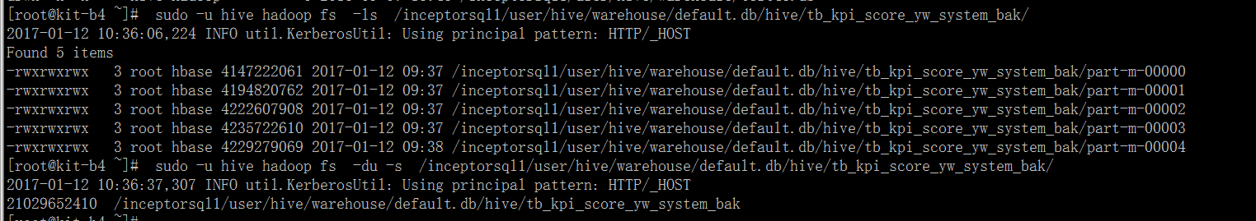

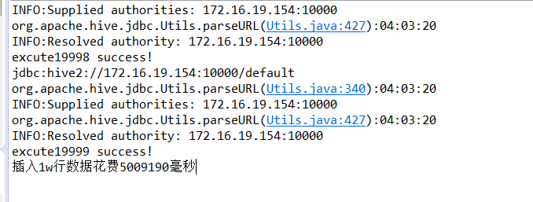

|  |  |  |  |  |
| --- | --- | --- | --- | --- |
| 测试入库行数 | 建立一次连接然后插入完以后释放资源 | 单条插入/花费时间 | 批量插入/花费时间 |  |
| 100 | 35572毫秒 | 39313ms | 5005毫秒 |  |
| 1000 | 451435毫秒 | 638241毫秒 | 46010ms |  |
| 1w |  | 5009190ms | 2148399毫秒 |  |
|  |  |  |  |  |

DM_A_TRANSFORMER表入库测试: 5行数据

|  |  |  |
| --- | --- | --- |
|  | 共计花费时间 多少毫秒32428 |  |
|  | 共计花费时间 多少毫秒23986 |  |
|  | 共计花费时间 多少毫秒24457 |  |
|  | 共计花费时间 多少毫秒24127 |  |
|  | 共计花费时间 多少毫秒22935 |  |

50行数据：

